Responding to feedback from patients - complaints, concerns, comments and compliments
1. Quick Reference Guide
An overview to complaint and concern handling is shown in the pathways below.
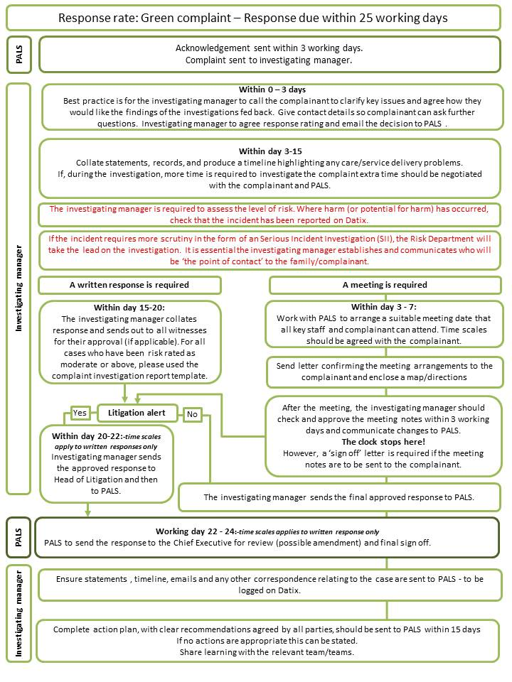
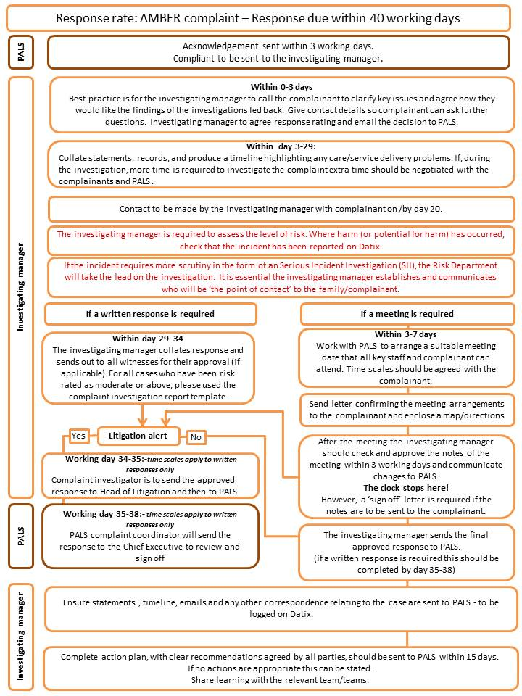
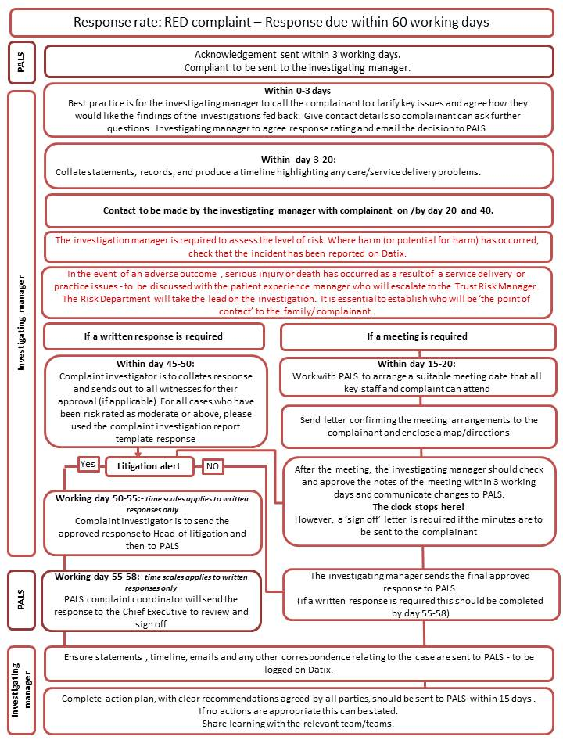
2. Introduction
Good complaint handling means:
- Getting it right
- Being customer focused
- Being open and accountable
- Acting fairly and proportionately
- Putting things right
- Seeking continuous improvement.
The purpose of this policy is to describe the way that the Trust manages all feedback in accordance with this.
Version | Updated By | Updated On | Description of Changes
 | Head of Customer Care | 23/08/2010 | This policy replaces the Complaints Policy
1.0 | Head of Customer Care | 27/10/2010 | This policy replaces the Complaints Policy
1.1 | Head of Customer Care | 08/02/2011 | Amendments to 2.1, 4.1 and appendices.
1.2 | Head of Customer Care | 24/03/2011 | Amendments to 2.7, 2.8 and 5.2
1.3 | Head of Customer Care | 20/09/2013 | Policy review date amended to 1st March 2014. Approved by OMB
1.4 | Head of Customer Care | 20/02/2015 | Advocacy Services Healthwatch Duty of Candour Removal of template letter appendices
1.5 | Head of Customer Care | 2018 | General update and two appendices deleted.
2.0 | Head of Patient Experience & Complaints Lead | May 2019 | Variable response times added. Policy updated to reflect change of name to PALS. Language simplified. Appendices updted. References updated
2.1 | HOPE | Aug 2020 | Typo in references amended
2.2 | Head of Patient Experience | June 2022 | Reference to related policy added (Allegations Against Staff Policy)
3. Definitions
A complaint is ‘an expression of dissatisfaction made to an organisation, either written or spoken', and whether justified or not, which requires a formal response from the Chief Executive. The Patients Association 2013. All complaints will follow the complaints process
A concern is a problem raised that can be resolved/responded to by the clinical or non-clinical teams concerned (within 25 working days). Concerns include issues where the patient/family member has said that they don’t want to make a formal complaint. The concern is acknowledged in the same way as a complaint, but if the issue can be resolved within 72 hours, a formal acknowledgement letter is not required.
A comment can also be logged with PALS. Comments are generally issues that the patient/family member want raised, but have said they do not require a response. Comments will be logged on the PALS’s data reporting system (Datix Web), and forwarded to the relevant directorate team for their information.
An enquiry is a problem raised that can be resolved/responded to straight away by PALS (usually by the end of the next working day or earlier). Enquiries are often requests for further information such as appointment times.
A compliment may be expressed by someone who is happy with any part of a service they receive. All compliments received by the Chief Executive's office or PALS are acknowledged and shared with the staff/department named. Many more compliments are received directly by wards/departments and their numbers are collated by PALS. Where staff or teams are complimented in Real time feedback or in the National Patient Surveys, a SOX will be completed and sent to the person/team. The CEO responds to cards/letters that are sent to her. Compliments sent via emails to the PALS inbox will be responded to by PALS and shared with the relevant person/team.
This policy aims to ensure that:
- All complaints are handled as quickly and efficiently as possible; and in accordance with national frameworks
- Staff feel empowered to deal with all feedback as it arises; doing so in an open and non-defensive way
- The learning from feedback is identified and used for improvement
- The complaints process is accessible, well publicised, open and transparent
- The complaints process supports those who find it difficult to complain.
The trust is committed to promoting equality and diversity. No patient, or anyone involved in the investigation and resolution of a complaint or concern will receive unfair treatment as a result of doing so, or on the grounds of age, race, ethnic or national origin, religious or equivalent belief system, gender, marital or partnership status, sexual orientation, disability or any other condition or requirement which cannot be justified and which causes disadvantage. Appropriate assistance including making reasonable adjustments will be offered to anyone who needs it.
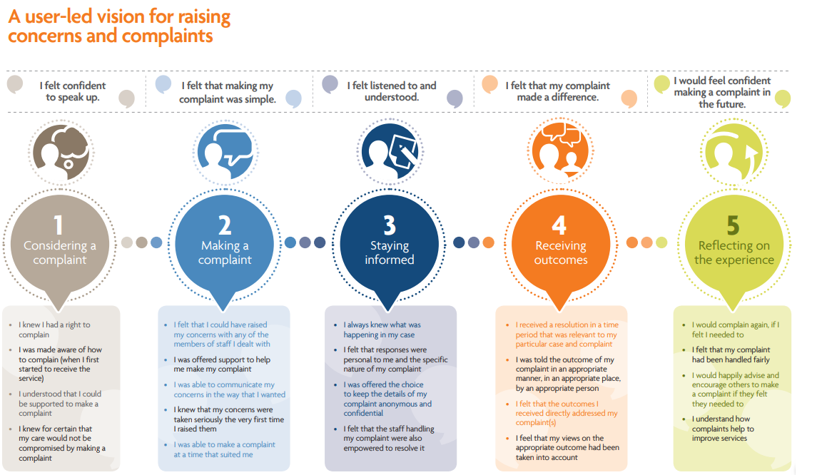
Staff groups affected
The Complaints Handling Policy applies to all staff. All staff have a responsibility to read this policy and to understand its impact on their area of work. Staff should be able to respond appropriately to a complainant and endeavour to achieve immediate resolution. If this is not possible, staff have the responsibility to escalate the feedback in accordance with this policy.
The PALS team and Complaint Manager are responsible for ensuring that all complaints are fully investigated and responded to within the agreed timeframes.
4. Management
Who might complain?
Complainants may be existing or former patients using the Trust's services and facilities, as well as relatives/carers. Members of hospital staff and other health professionals including the GP may also complain about aspects of a patient's care or raise it through the Freedom to Speak Up: Raising Concerns Policy.
A complaint may be made by the person who is affected by the action, or it may be made by a person acting on behalf of a patient in any case where that person:
- is a child (an individual who has not attained the age of 18);
In the case of a child, we must be satisfied that there are reasonable grounds for the complaint being made by a representative of the child, and additionally that the representative is making the complaint in the best interests of the child.
- has died;
In the case of a person who has died, the complainant must be the personal representative of the deceased. Salisbury NHS Foundation Trust needs to be satisfied that the complainant is the personal representative. Where appropriate we may request evidence to substantiate the complainant's claim to have a right to confidential information about the deceased patient's medical care.
- has physical or mental incapacity;
In the case of a person who is unable by reason of physical capacity, or lacks mental capacity within the meaning of the Mental Capacity Act 2005, to make the complaint themselves, Salisbury NHS Foundation Trust needs to be satisfied that the complaint is being made either at the express request of a physically disabled patient or in the best interests of the person lacking mental capacity on whose behalf the complaint is made. Appendix [ lack mental capacity pathway].
- has given consent to a third party acting on their behalf;
In the case of a third party pursuing a complaint on behalf of the person affected we will request the following information:
- Name and address of the person making the complaint;
- Name and either date of birth or address of the affected person; and
- Contact details of the affected person so that we can contact them for confirmation that they consent to the third party acting on their behalf.
This will be documented in the complaint file and confirmation will be issued to both the person making the complaint and the person affected.
- Has delegated authority to act on their behalf, for example in the form of a registered Power of Attorney which must cover health and welfare (as distinct from property and financial affairs).
- Is an MP, acting on behalf of and by instruction from a constituent.
If Salisbury NHS Foundation Trust is of the opinion that a representative does or did not have sufficient interest in the person's welfare, or is not acting in their best interests, we will notify that person in writing.
The complainant must be told that, in order not to be in breach of patient confidentiality, any matters relating to the patient's care and treatment can only be answered with the patient's consent. (This does not mean that the matters raised cannot be investigated, but it does mean that the Trust is obliged not to divulge any confidential information about the patient's care and treatment in its response)
Time limit for making a complaint
The timescale in which a complaint can be made is 12 months from the date on which the matter occurred, or the matter came to the notice of the complainant. The Trust has the discretion to investigate beyond this time, especially if there are good reasons for a complaint not having been received with the 12 months and it is still possible to investigate the case effectively. Where it is decided not to investigate, the complainant will have the opportunity to approach the Parliamentary and Health Service Ombudsman
What people cannot complain about
- A complaint made by an NHS body about the functions of Salisbury NHS Foundation Trust.
- Staff working within, or contracted to, Salisbury NHS Foundation Trust cannot use the arrangements to complain about employment, contractual or pension issues.
- Complaints that have already been investigated under the complaints regulations.
- Complaints arising out of the alleged failure to comply with a data subject request under the Data Protection Act 1998.
- Complaints arising out of an alleged failure by an English NHS body to comply with a request for information under the Freedom of Information Act 2000
Complaints and disciplinary action
A complaint can be investigated even if disciplinary action is being considered or taken against a member of staff, provided the Trust follows good practice around restrictions in providing confidential/personal information to the complainant.
Whist the complaints handling procedures will operate alongside the disciplinary arrangements, the two arrangements will remain separate.
A complaint can be investigated even if disciplinary action is being considered or taken against a member of staff, provided the organisation follows good practice around restrictions in providing confidential/personal information to the complainant. The purpose of the complaints procedure is not to apportion blame amongst staff but to investigate complaints with the aim of satisfying complainants and to learn any lessons for improvements in service delivery. If, however, a complaint identifies information about a serious matter which indicates a need for disciplinary action, this will be managed under the Trust’s Disciplinary Policy.
Complaints concerning allegations against staff
Salisbury NHS Foundation Trust holds a separate policy which outlines the necessary arrangements in the event that a complaint is raised in connection with an allegation against a member of staff.
Allegations are defined as follows:
- Behaviour that has in some way harmed, or may have harmed, a child or adult;
- Possibly committed a criminal offence against, or related to, a child or adult;
- Behaved towards a child or adult in a way that may indicate s/he is unsuitable to work with children or adults at risk of abuse or neglect; and/or
- Believed to have engaged in an activity which may indicate that s/he is unsuitable to work with children or adults or could not hold the trust of the public in so doing e.g. accessing or taking inappropriate images/information of patients, visitors or employees on mobile devices, computers or smartphone and or sharing or posting them via the internet and Social Media.
In any of these instances the following should be consulted in conjunction with this policy: Allegations Against Staff Policy.
Cases involving legal action
On receipt of a complaint where legal action is being taken or the police are involved, the discussions will take place with the relevant authority, e.g. legal services, the police, or the Crown Prosecution Service, to determine whether progressing the complaint might prejudice subsequent legal or judicial action. If so, the complaint will be put on hold, and the complainant advised of this fact. If not, an investigation into the complaint should take place.
Complaints Investigation and Risk Management
The procedures for managing complaints, incidents and claims for negligence are dealt with under separate policies. However, if during the course of investigating an incident, a complaint is received, the incident procedure should take precedence in terms of investigation. If the investigation of a complaint reveals the need to take action under the serious incident procedure, the investigator should inform the Risk Team and Complaints Lead. Again the incident procedure should take preference in terms of investigation.
Any complaints that involve a sudden unexpected death, allegation of abuse, potential safeguarding issues, suicide or serious self-harm, data loss and information security should be immediately escalated to the Complaint Lead who will discuss the management of the complaint with the most appropriate Head of Service/Lead Clinician. Please refer to the serious incident requiring investigation policy on MicroGuide, for a full list of notifiable incidences.
However, during the course of the complaint investigation, it is noted that potentially serious harm has occurred, it is the Investigating Manager’s responsibility to escalate their concerns to the Complaint Lead and the Head of Risk - in accordance with the red response rate pathway (see above). If it is felt that the incident should be investigated under the Serious Incident Investigation (SII) or Clinical Review (CR) process, the Head of Risk will keep the complainant informed of the progress of the investigation. If the person has raised serious concerns that are not being investigated under the serious incident investigation, or question raised within the complaint is not covered by the scope of the review, then they will be investigated under a Complaint Investigation Process. It is essential that lines of communication is maintain between the Risk department, PALS and the Investigating Manager; to ensure an cohesive approach to the feedback of the complaint/ SII/ CR report.
Complaints received about other NHS Bodies or social services
If a complaint is received about other NHS bodies or Social Services, consent from the complainant must be sought before transferring the complaint to that organisation. Were a complaint is are a mixture of health and social care issues, it will be agreed with the complainant, which organisation will lead and co-ordinate the final response.
If the Trust receives a written complaint that involves another agency, for example, the Police, the Trust will work jointly with an agreed point of contact, to ensure all matters are fully investigated.
Complaint investigation process
All complaints are logged on Datix Web, and sent by the PALS team to the relevant Directorate Manager (DM). The DM will assign an investigating manager. The investigating manager, together with the PALS complaint coordinator, will agreed upon a response rag rating (RED/ AMBER/ GREEN)-Please refer to Appendix A. (The rag rating relates to the time require to conduct a full investigation and is not associated with the Risk Matrix). There is flexibility within the pathways should investigation become more complex; therefore additional time is required.
Please refer to the Response Rate Flow charts for full details of the investigation process.
Where the ‘Amber flow chart (40 days)’ or ‘ Red flow chart (60 days)’ pathway is followed the investigating manager is responsible for contacting the complainant at the additional ‘touch points’ as identified in the flowcharts.
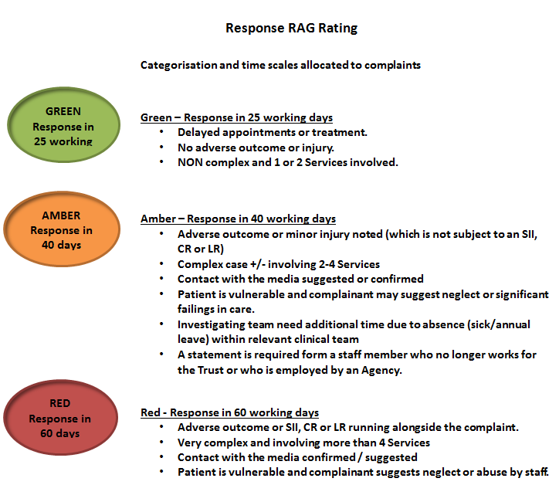
5. Roles and Responsibilities
Chief Executive
The Chief Executive is the designated responsible person whose duty it is to ensure overall compliance with the Statutory Instrument. The Chief Executive designates the day to day management of the process to the Complaints Manager. The Chief Executive will sign all complaint acknowledgement letters within three working days of receipt of the complaint. A copy of the Trust's leaflet 'Comments, Concerns, Compliments and Complaints', which explains how the complaint will be handled will be enclosed. The response letter will be signed by the Chief Executive, and in her absence, responses will be signed by the Deputy Chief Executive.
Head of Patient Experience
The prime responsibility is to oversee the complaints handling procedure, provide guidance and support, and to provide the Trust with an overview of its complaints.
The Complaints Lead
The complaints Lead has the delegated responsibility to manage the complaint procedure on behalf of the Chief Executive.
The Complaints Lead will co-operate with the requirements of the Parliamentary and Health Service Ombudsman (PHSO) by providing information, files and copies of relevant medical records if required.
PALS Team
The Patient Advice and Liaison Team (PALS) are responsible for trying to resolve concerns/complaints when the issue if brought to their attention or referring the concern to the appropriate Directorate Management Team member. If the issues cannot be resolved quickly then they will co-ordinate the concerns/complaints procedure, ensuring compliance with the complaint regulations, agreeing a plan with the complainant for the management of the complaint.
The PALS team will:
- Contact the complainant to discuss the complaint at the outset and identify their preferred outcome - what they hope to achieve from the process if this has not already been established; identify and explain any consent issues to the complainant and assess what further action might best resolve the complaint e.g. a meeting with staff.
- Prepare an acknowledgement letter for the Chief Executive to sign within three working days of receipt. The acknowledgement will indicate that a written response from the Chief Executive for complaints or relevant manager for concerns will follow within an agreed timescale and will include a leaflet about the Trust's Comments, Concerns, Complaints and Compliments Procedure, which also gives information about local advocacy services and the Parliamentary and Health Service Ombudsman (PHSO).
- Acknowledge complaints and concerns received by email via the same medium and will ask the sender to provide a postal address so that all future correspondence can sent there. It is not possible to be certain that the sender is who they appear to be, that the message will be read by them and that they understand or accept the risks. Whilst we understand the need for people to communicate by e-mail, to ensure security of information, the Trust must positively identify the named individual and address. (Acceptable use of Email and SMS Text Messaging policy).
- Acknowledge verbal complaints with a written record of the conversation sent to the complainant. The complainant will be asked to confirm if the record clearly captures the issues they want investigating or if they wish to add or amend the information.
- Record all relevant information about the issue on Datix and set up the agreed response timescale alerts.
- Send complaints out to the relevant investigating manager (copying in anyone named in the complaint)
- Track complaints and send reminders to facilitate the meeting of deadlines and keep the complainant informed of any delays.
- Telephone/e-mail the Investigating Manager one week before the final deadline to find out if there are any problems with the investigation and to offer assistance by contacting the complainant and agreeing a longer timescale, giving the reasons for the delay. Record the conversation and set the new timescales on Datix.
- Check completed response letters for content, format, grammar and spelling, before forwarding to the Complaints Lead. After sign-off by the Chief Executive, PALS will send the signed letter of response to the complainant and a copy to all staff named in the letter.
Directorate Management Team (Investigating Manager)
Directorate Management Teams have the responsibility to resolve concerns face-to-face or over the telephone where they can. If the matter is more complex then they will undertake an investigation, ensuring that the complainant's concerns are fully addressed within the agreed deadlines.
The Investigating Manager will undertake a preliminary assessment of how best to investigate the complaint and should make contact with the complainant within 72 hours.
It is the responsibility of the complaint investigating manager to make regular contact with the complaint at various points during the investigation. The number of contacts depends largely on the allocated response rate. See flow charts above.
The investigating manager must provide support to staff involved in an investigation, particularly those named, and make sure they are aware of the contents of the complaint and response. If a named member of staff has left the Trust, the Investigating Manager has the responsibility to ensure all efforts are made to obtain their comments, particularly if harm has been alleged.
If the complaint involves a junior member of staff, the Investigating Manager must obtain a senior review as well as obtaining comment from the junior member of staff involved. If the complaint involves a junior doctor, the Investigating Manager must let the Foundation Programme Director know. The draft complaint response letter needs to be shared and agreed by all named in the response and by those who have contributed to the investigation.
If admissions of error are to be made, the draft response must be shared with the Head of Litigation. If the complainant is explicitly requesting compensation/ recompense, findings of the investigation must be shared with the Head of Litigation.
If harm is alleged to have been caused, Investigating Managers must assure themselves of the evidence when they read the medical records.
The draft response must be factually correct and should:
- Include an apology
- Address each of the points raised with a full explanation or give the reason(s) why it is not possible to comment on a specific matter
- Give specific details about the investigation
- Give details of action taken as a result of the complaint and what lessons have been learned
- Include details of further action the complainant can take, including an offer to meet with the service, if appropriate, and the details for the PHSO
To minimise complaint re-occurrence, the Investigating Manager must ensure that agreed actions arising out of investigations are shared with and implemented with the appropriate teams/departments.
To ensure improvements arise out of complaints, action plans (Appendix B) must be completed and monitored following the investigation of all complaints. The Action Plan must be sent to PALS at the end of the investigation when the draft response is sent. The information from the Action Plan will be recorded on Datix and timescales set for follow-up. PALS will e-mail the Investigating Manager or person responsible for implementing the action for an update/closure.
Managers
It is part of the role of the manager to ensure that staff are helped and supported throughout the handling of any complaint.
All staff
Staff should ensure that complainants, having made a complaint, are assured that it will not prejudice the patient's future treatment and care. The Trust policy and procedure for handling complaints is considered as part of the ward/department induction.
Front line staff will distinguish those serious issues that, even if raised verbally need to be brought to the attention of senior managers within the Trust.
Safeguarding Adults
The Trust has in place systems and processes to promote the safeguarding and wellbeing of patients. These are reflective of local and national guidelines. It is important that when a complaint is received, consideration is given as to whether it may meet the Safeguarding Adults threshold and this must be done in a timely manner in line with the Safeguarding Vulnerable Adults/Adults at Risk Policy.
Before commencing a complaint investigation, PALS will review the complaint for potential safeguarding adult issues. If there are safeguarding concerns these must be escalated to the Trust Adult Safeguarding Lead. The Adult Safeguarding Lead will consider the complaint and confirm whether there are safeguarding issues that require referral to the appropriate social care, learning disability or mental health team. This may mean that the formal complaint investigation has to be delayed although it should be remembered that the two investigations can run in parallel if it is agreed that this would not compromise the safeguarding investigation.
Parliamentary and Health Service Ombudsman (PHSO)
The PHSO investigates complaints about the National Health Service and is completely independent of the NHS and the government. The PHSO will consider cases where the complainant is not satisfied with the Trust's efforts to resolve their concerns at a local level. The complainant has to send their complaint to the PHSO no later than a year from the date when they became aware of the events, which are the subject of complaint. The PHSO can sometimes extend the time limit, but only if there are special reasons.
The PHSO can investigate complaints about hospitals or community health services which are about:
- a poor service;
- failure to purchase or provide a service a complainant is entitled to receive;
- mal-administration - that is administrative failures such as unavoidable delay, not following proper procedures, rudeness or discourtesy, not explaining decisions or not answering the complaint fully and promptly;
- complaints about the care and treatment provided by a doctor, nurse or other health care professional;
- other complaints about family doctors (GPs) or about dentists, pharmacists or opticians providing a NHS service locally.
The PHSO cannot look into:
- complaints which one could take to court or an independent tribunal - unless the PHSO does not think it reasonable for the complainant to do so;
- personnel issues such as appointments of staff, pay or discipline;
- commercial or contractual matters, unless they relate to services for patients provided under a NHS contract;
- properly made decisions an NHS authority or other body or individual providing NHS services has a right to make, even if the Complainant does not agree with the decision;
- services in a non-NHS hospital or nursing home, unless they are paid for by the NHS;
- complaints about government departments, such as the Department of Health;
- complaints about local authority departments, such as social services.
The PHSO will decide whether or not an investigation will be carried out. If the PHSO cannot look into a complaint or decides not to, the complainant will be told why. If the PHSO decides to investigate, the complainant and the Trust will be sent a statement of complaint, which sets out what matters the PHSO, will look into. The complainant and relevant hospital staff may be interviewed by the PHSO's investigator. At the end of the investigation, a report will be sent to the complainant and the Trust. If the complaint is found to be justified, the PHSO will seek for the complainant an apology or other remedy. Sometimes that may include getting a decision changed, or a repayment of unnecessary costs to patients or their relatives/carers. The PHSO does not recommend damages (compensation). The PHSO may also call for changes to be made so that what has gone wrong does not happen again. Where the Trust tells the PHSO that it will make such changes, the PHSO checks that it has done so.
Following receipt of the PHSO's draft report, this will be circulated to the relevant staff involved in the case for their comments. The Trust must confirm to the PHSO that the content is accurate and state whether it accepts the PHSO's decision.
Further to receipt of the final report, if recommendations are made the Trust must convene a meeting of the relevant senior staff to review the recommendations and carry out the necessary actions. Clear action planning must be carried out. It is likely that the Ombudsman will wish to review actions taken as a result of their recommendations three months later. The Complaints Lead will oversee this process.
A complaint to the PHSO represents the final stage in the procedure for pursuing a complaint. The PHSO's decision on a complaint is final.
Healthwatch
Healthwatch's sole purpose is to understand the needs, experiences and concerns of people who use health and social care services and to speak out on their behalf. People who want to make a complaint about a particular service can contact Healthwatch to find out how to get help with making their complaint.
6. Staff information
Meetings
As part of the local resolution process and in agreeing with the complainant how they wish their concerns to be handled, all teams are encouraged to meet with the complaint at an early stage.
Once a meeting has been agreed the complainant will be asked to provide a list of questions to form an agenda so the meeting can be structured with the most appropriate staff in attendance. Meetings will take place in a sensitive venue. Complainants requiring support will be advised to contact their local Advocacy Service. A letter will be sent to the complainant giving details of the meeting and who will be attending.
Staff should attend a pre-meeting to discuss the case. The meeting will have a chair/facilitator, usually the investigating manager, and someone to record discussion points and actions. If necessary, staff involved in the complaint will then meet to discuss the outcome and agree any further actions that need to be taken to achieve local resolution for the complainant.
The action points will be circulated to all staff members involved in the meeting for an accuracy check. To ensure that complaint/concern time scales are met, any requests for changes to the action points must be sent promptly (within 72 hours).
Statutory Duty of Candour
If an incident has caused moderate or major harm we must tell the patient about it swiftly and honestly. We also have a duty to support the patient by allowing a member of the family, carer or a healthcare professional that the patient has confidence in to be present when they tell the patient what has happened. Ongoing support and treatment to reduce the harm must be provided. This might be from a different clinical team or hospital if the patient wishes.
Further guidance is available in the Trust's Adverse Event Reporting Policy and the Duty of Candour and Being Open Policy. The duty, which will be monitored by the Care Quality Commission (CQC), will apply to all NHS organisations.
Records
Complaint correspondence will be kept separate from health records, subject to the need to record any information, which is strictly relevant to their clinical management in the patient's health record. No complaint correspondence is to be filed in the patient's health record. This instruction covers the initial letter of complaint and the final letter of reply, as well as internal correspondence. The master files of all statements and correspondence of meetings are held on Datix.
Statements
With an increasing number of complex queries and complaints, it is becoming more common for staff to be asked to provide statements as a result of a complaint/claim/untoward incident. When writing a statement, it is important to remember that, although the majority of statements will go no further, a statement may be copied to the complainant, PHSO, the Coroner or used as evidence in defending a legal claim. Please remember, however, that the Trust indemnifies its entire staff and will be responsible for any complaint and claim made (see Writing Statements appendix).
Mediation
Some complaints are difficult to resolve, particularly when there is a breakdown in a relationship between staff and patients/relatives/carers. In these cases mediation can be used.
Mediation is a process that complements the Trust's formal arrangements for dealing with complaints. It offers early assistance before problems escalate into major issues for all concerned.
The mediator's role is purely to mediate between the parties to restore communication. The mediator is not expected to get involved in the investigation of the complaint. The process and principles used by the mediator are clearly set out in the Trust's Mediation Scheme.
To request a Mediator, you can e-mail mediation@salisbury.nhs.uk
Advocacy Services
If someone wants to raise concerns or make a complaint it is important to let them know what support is available. There is a number of advocacy services available depending where the patient lives. These services are free, independent and confidential and will listen to a person's concerns about their NHS treatment. Advocates can help people write effective letters to the right people; prepare them for and go to meetings with them; contact and speak to third parties if they wish them to and help people think about whether they are happy with the responses they receive from NHS organisations.
Persistent and unreasonable complainants
Persistent and unreasonable complainants are those that raise the same or similar issues repeatedly, despite having received a full response to all the issues they have raised. If, following a review of the complaint, the complainant is persistent or unreasonable in their manner of engaging with the Trust, it may be appropriate to apply a degree of restriction on their frequency and mode of contact. This would include complainants that:
- Refuse to accept the remit of the process to be undertaken as described to them.
- Request actions that are not compatible with the process or place unreasonable demands on staff.
- Change the basis of the concern or complaint or introduce trivial or irrelevant information and expect these to be taken into account when they have already agreed to a plan and specific issues to be responded to.
- Make excessive telephone calls or send excessive numbers of e-mails or letters to staff.
- Submit concerns or complaints about the same issues as have previously been appropriately and fully considered and responded to.
- Fail to engage with staff in a manner which is deemed appropriate: e.g. repeatedly using unacceptable language; refusing to adhere to previously agreed communication plans or behaving in an otherwise threatening or abusive manner on more than one occasion, having been warned about this.
- Repeatedly focus on conspiracy theories and/or will not accept documented evidence as being factual.
The Head of Patient Experience/Complaint Lead, in agreement with the Chief Executive, will determine the point at which a complainant will be considered to be persistent and unreasonable. Below are some possible courses of action that may help to manage complainants who have been designated as persistent and/or unreasonable.
- Placing time limits on telephone conversations and personal contacts.
- Restricting the number of calls that will be taken or made.
- Requiring contact to be made with a named member of staff.
- Requiring contact to be made through a third person, such as an advocate.
- Limiting the complainant to one mode of contact e.g. in writing only.
- Requiring any personal contact to take place in the presence of a witness.
- Refusing to register and process further concerns or complaints about the same matter.
- Informing the complainant that future correspondence will be read and placed on file, but not acknowledged.
- Advising that the organisation does not deal with correspondence that is abusive or contains allegations that lack substantive evidence. Request that the complainant provide an acceptable version of the correspondence or make contact through a third person to continue communication with the organisation.
- Asking the complainant to enter into an agreement about their conduct.
- Advise that irrelevant documentation will be returned in the first instance and (in extreme cases) in future may be destroyed.
Once a restriction is put in place, a letter should be issued by the Chief Executive to inform the complainant about the decision; what it means for their future contact with the organisation; how long those restrictions will remain in place; and what they can do to have their position reviewed.
Private patients
This procedure covers any complaint made about staff or facilities relating to private health care on Trust premises but does not cover the private medical care provided by a consultant outside her/his NHS contract.
7. Process for monitoring compliance, effectiveness and risk management
Monitoring
The Complaint Lead is responsible for the monitoring of individual complaints against agreed timescale and responsibilities, in liaison with the Directorate Management Teams.
The Head of Patient Experience will produce quarterly summarised reports of complaints received to the Clinical Management Board, Clinical Governance Committee and the Trust Board that will include qualitative and quantitative analysis of key issues found in complaints. The report will include actions taken by the Directorate Management Teams to improve services as a result of complaints. These reports will also be shared with the Commissioners and at the Governor's meetings. The conclusions and recommendations outlined in a PHSO's final report, together with any action to be taken by the Trust as a result of these investigations, will also be included. The Clinical Governance Committee reports into the Trust Board.
A quarterly KO41(A) return will be completed and returned to NHS Digital.
Complaints Management Questionnaire
A complaints management questionnaire will be sent to each complainant on conclusion of the complaint unless it is excluded under the following exceptions:
- The complainant has contacted the PHSO (as it is felt that if they have done so they have already demonstrated their dissatisfaction with the complaint process).
- The complaint is re-opened and still under investigation.
- The complaint is subject to an ongoing clinical review.
Complaints provide a unique insight into the complainant's experience of our services and often highlight where service improvements can be made. It is very important to us that complainants not only feel able to raise their concerns, but are happy with the actions that we take as a result.
8. Training
Investigator Training
All staff with a responsibility to lead on complaint or incident investigations should attend Investigator Training. Training dates are publicised on the MLE7
Publicity
Leaflets informing patients and visitors of the Trust's Complaints Procedure will be displayed throughout the Trust. The Complaints process is also publicised on the Trust's website.
Translating and Interpreting
The Trust recognises that on occasions complainants may experience difficulties in pursuing their complaint due to language or communication barriers. PALS will ensure that appropriate support is made available to complainants
Special Needs
PALS will ensure that wherever possible the individual needs of complainants are identified and met. This will include meeting the needs of people with learning disabilities, physical disabilities or communication problems such as hearing or visual impairment.
Out-of-hours help
The PALS team is available between 8.30am and 4.30pm, Monday to Friday. Issues raised outside these hours should be directed to the appropriate Ward/Service Manager, or to the duty on-call manager.
Any immediate clinical need must be passed to the appropriate clinician.
If the concerns do not require immediate action, as much detail as possible, including the person’s contact details, should be obtained and forwarded to the PALS department by the next working day. The complainant should be informed of the action taken and given the direct dial telephone number for PALS.
9. References
1. Good Complaints Handling 2013. The Patients Association. Available at: https://www.noeccn.org.uk/resources/Documents/Education%20Group/Resources/Good-Practice-standards-for-NHS-Complaints-HandlingSept-2013.pdf
General Data Protection Regulations 2016: https://gdpr-info.eu/

Data Protection Act 2018: https://www.legislation.gov.uk/ukpga/2018/12/contents/enacted
Being Open – communicating patient safety incidents with patients their families and carers, (2013) National Patient Safety Agency. Available at http://patientsafety.health.org.uk/resources/being-open-communicating-patient-safety-incidents-patients-their-families-and-carers
The NHS Constitution – The NHS belongs to us all (2015) Department of Health. Available at: https://www.gov.uk/government/publications/the-nhs-constitution-for-england/the-nhs-constitution-for-england
Ombudsman's Principles, (2009) Parliamentary and Health Service Ombudsman. Available at: https://www.ombudsman.org.uk/sites/default/files/page/0188-Principles-of-Good-Complaint-Handling-bookletweb.pdf
My expectations for raising concerns and complaints. Local Government Ombudsman & Healthwatch November 2014. Available at: https://www.ombudsman.org.uk/sites/default/files/Report_My_expectations_for_raising_concerns_and_complaints.pdf
Statutory Instrument (2009) The Local Authority Social Services and National Health Service Complaints (England) Regulations - www.legislation.gov.uk
WEBSITES
Health Service Ombudsman - www.ombudsman.org.uk
Care Quality Commission - www.cqc.org.uk
NHS Litigation Authority – www.nhsla.com
Statuatory regulations - Local Authority Social Services and National Health Service Complaints (England) Regulations 2009 http://www.legislation.gov.uk/uksi/2009/309/contents/made
Ask Listen Do
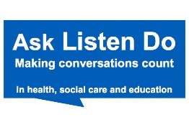
Ask Listen Do supports organisations to learn from and improve the experiences of people with a learning disability, autism or both, their families and carers when giving feedback, raising a concern or making a complaint. It also makes it easier for people, families and paid carers to give feedback, raise concerns and complain.
Read the Easy Read Leaflet here
Access the Easy Read feedback form here
PALS have copies of the leaflet and the feedback form for patients/families to use
Postholder responsible for document: Head of Patient Experience and Complaints Lead
Last updated: August 2020
Next due for review: August 2022

